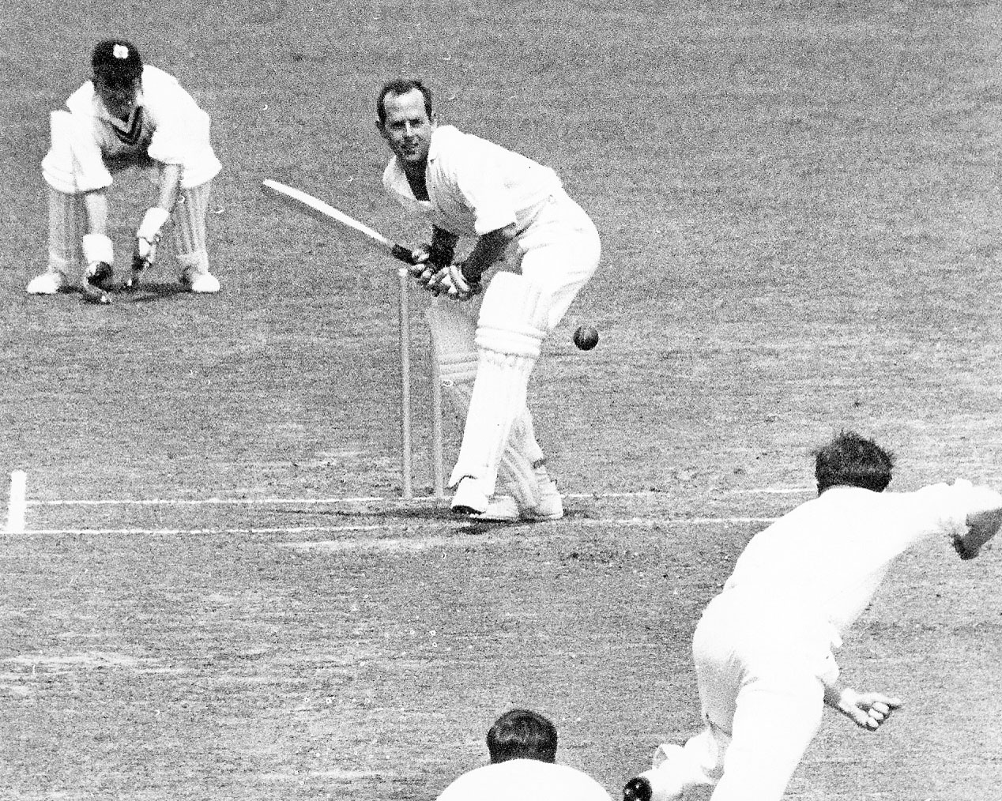

**BF Hastings drives JP Flaherty, BD Milburn wicketkeeper. Hastings made 46. Lancaster Park 10 February 1966**

**Canterbury 291 and 181/7dec Otago 211 and 172/3. Match drawn**